
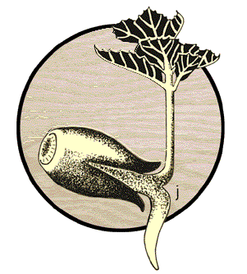
STOP THE SPREAD
OF
SUDDEN OAK DEATH



Plants in this area are infected with the pathogen, Phytophthora ramorum, that causes Sudden Oak Death. This deadly fungus-like organism is killing tanoak, coast live oak, black oak, and Shreve’s oak in California’s coastal counties. It also infects many other trees and shrubs in this area, including bay, madrone, huckleberry, and rhododendron.

Help prevent the spread of this serious plant pathogen by taking the following precautions.
WHILE HERE…
- Park your vehicle only in designated parking areas.
- Stay on established trails - respect trail closures.
- Do not collect any plant material (including leaves, twigs, wood).
- Do not collect soil and avoid muddy areas.
BEFORE GOING TO UNINFESTED AREAS…
- Clean soil and mud off of shoes, mountain bikes, horse’s hooves, and pet’s paws.
- Wash mud or soil off of tires, wheel wells and the undercarriage of your vehicle at the nearest automated car wash.

For further information visit www.suddenoakdeath.org or call your phone #

Guidelines provided by the California Oak Mortality Task Force are based on the best current knowledge and may change as new information becomes available.

July 31, 2026
DON’T TAKE IT HOME!

